9
9

ORIGINAL
“ EFRUZHU ONCOTHERAPY
DUAL – BINARY OPPOSITE COMPOUND
GEAR – WHEEL MODEL ”
“ EFRUZHU ONCOTHERAPY DUPLEX – DUALIS OPPOSITUS
COMPOSİTUS MACHINA EXEMPLARE ”
CD : CONVENTIONAL DRUGS (CHEMOTHERAPEUTIC AGENTS ,ANTICANCER AGENTS , ANTINEOPLASTIC DRUGS )
ND : NATURAL DRUGS ( HERBAL MEDICINES )

MA:MACROCYCLE
TOTAL ANTICANCER THERAPY

MI : MICROCYCLE

CD - ND
CD - ND

CD - ND
CD - ND

MA :MACROCYCLE = MACROTURNOVER
MI : MICROCYCLE = MICROTURNOVER

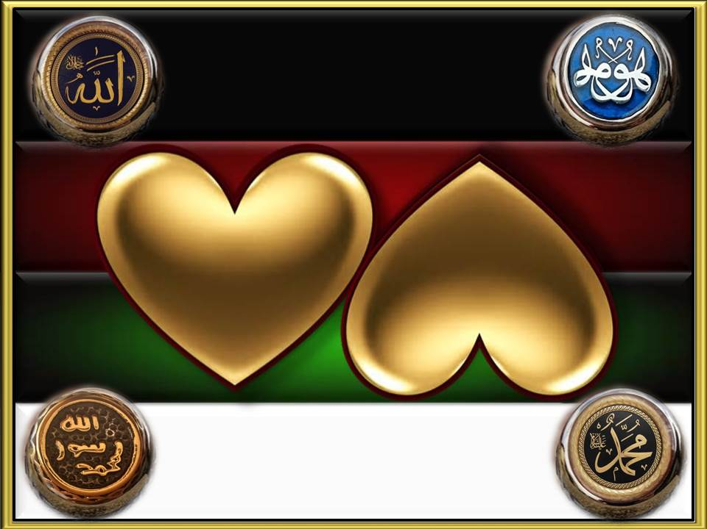

APEX DEGREE PHILOSOPHER EFRUZHU PHRMP
MOLECULAR & CELLULAR & CLINICAL MEDICAL ONCOLOGY
EXPLORATIONS AND DISCOVERIES
NORTH CYPRUS TURKISH CYPRIOT

