©® ©®
EFRUZHU ABSOLUTE ANY STAGE ONCOTHERAPY DISCOVERY
NF-kB  DRUGHU ( N ) | HDAC – DNMT  DRUGHU ( E ) | INFLAMMATION  DRUGHU ( B ) | GLYCOSAMINOGLYCAN  DRUGHU ( E ) | ELECTROLYTE  DRUGHU ( V ) | HIGHENERGY  DRUGHU ( İ ) | SELFSIGNALING  DRUGHU ( H ) | HERBAL  DRUGHU ( U ) | HOLYDIVINEHU  DRUGHU ( HD )
1.VELCADE | X | C | G | J | 1.RAHMANHU  DRUGS | 1.ALİMHU  DRUGS | T | 1.QURAN  LISTENING
 | 1.ISTODAX | 1.HEXADROL | 1.THALIDOMIDE | 1.RINGERS | 2.MEVLAHU  DRUGS | 2.HABİRHU  DRUGS | 1.KAHHARHU  DRUGS | 2.QURAN  READING
 | 2.FARYDAK | 2.DEPO-MEDROL | 2.LENALIDOMIDE | 2.LACTATED  RINGERS | 3.HAKHU  DRUGS |  | 2.KADİRHU  DRUGS | 3.REED FLUTE  LISTENING
 | 3.ZOLINZA | 3.PREDNISONE | 3.POMALIDOMIDE | 3.ISOLYTE | 4.HALIKHU  DRUGS |  | M | 4.ISLAMIC  SUPPLICATION
 | 4.BELEODAQ | 4.PREDNISOLONE  SODYUM | M | K |  |  | 1.TABİBHU  DRUGS | 5.ISLAMIC  WORSHIP
2.KYPROLIS | 5.TRICHOSTATIN  A | 5.CORTISONE  ACETATE | 1.TABİBHU  DRUGS | 1.MALİKHU  DRUGS |  |  | 2.ŞAFİHU  DRUGS | 6.ISLAMIC  CHANT ZİKİR
 | 6.VALPROIC ACID | 6.BETAMETHASONE | 2.ŞAFİHU  DRUGS | 2.MELIKHU  DRUGS |  |  |  | (ALLAH, HU,  ALLAHU ,
 |  |  |  |  |  |  |  | LAİLAHEİLLALLAH)
 | Y
 | 1.VIDAZA
 | 2.DACOGEN
3.NINLARO
 |  |  |  |  |  |  | H | 7.ALLAHU1  LOVE
 |  |  |  |  |  |  | 1.ALİMHU  DRUGS | 8.HZ.MUHAMMED  LOVE
 | Z | S |  |  |  |  | 2.HABİRHU  DRUGS
 | 1.AMNESTEEM | 1.MOBIC |  |  |  |  | K
 | 2.CLARAVIS | 2.CELEBREX |  |  |  |  | 1.MALİKHU  DRUGS
 | 3.MYORISAN | 3.PIROXICAM |  |  |  |  | 2.MELİKHU  DRUGS
 | 4.ZENATANE | 4.VIOXX |  |  |  |  | İ
 | 5.ACCUTANE | 5.ASPIRIN |  |  |  |  | 1.RAHMANHU  DRUGS
 | 6.ROACCUTANE | 6.ASSURED |  |  |  |  | 2.RAHİMHU  DRUGS
 | 7.ABSORICA | 7.NEXCEDE |  |  |  |  | 3.HAKHU  DRUGS
 | 8.VEZANOID | 8.DICLOFENAC  POTASSIUM |  |  |  |  | 4.HALİKHU  DRUGS
 | 9.TOCTINO | 9.SULINDAC
 | 10.TARGRETIN | T
 | 11.ACITRETIN | 1.KAHHARHU  DRUGS
2.KADİRHU
DRUGS

N1 | EX1Y1Z1 | BC1 | EG1 | VJ1 | İ4 | H1 | UT1 | HD1
N1 | EX1Y1Z1 | BC1 | EG1 | VJ1 | İ4 | H1 | UT1 | HD2
N1 | EX1Y1Z1 | BC1 | EG1 | VJ1 | İ4 | H1 | UT1 | HD3
N1 | EX1Y1Z1 | BC1 | EG1 | VJ1 | İ4 | H1 | UT1 | HD4
N1 | EX1Y1Z1 | BC1 | EG1 | VJ1 | İ4 | H1 | UT1 | HD5
N1 | EX1Y1Z1 | BC1 | EG1 | VJ1 | İ4 | H1 | UT1 | HD6
N1 | EX1Y1Z1 | BC1 | EG1 | VJ1 | İ4 | H1 | UT1 | HD7
N1 | EX1Y1Z1 | BC1 | EG1 | VJ1 | İ4 | H1 | UT1 | HD8

N2 | EX1Y1Z1 | BC1 | EG1 | VJ1 | İ4 | H1 | UT1 | HD1
N2 | EX1Y1Z1 | BC1 | EG1 | VJ1 | İ4 | H1 | UT1 | HD2
N2 | EX1Y1Z1 | BC1 | EG1 | VJ1 | İ4 | H1 | UT1 | HD3
N2 | EX1Y1Z1 | BC1 | EG1 | VJ1 | İ4 | H1 | UT1 | HD4
N2 | EX1Y1Z1 | BC1 | EG1 | VJ1 | İ4 | H1 | UT1 | HD5
N2 | EX1Y1Z1 | BC1 | EG1 | VJ1 | İ4 | H1 | UT1 | HD6
N2 | EX1Y1Z1 | BC1 | EG1 | VJ1 | İ4 | H1 | UT1 | HD7
N2 | EX1Y1Z1 | BC1 | EG1 | VJ1 | İ4 | H1 | UT1 | HD8

N3 | EX1Y1Z1 | BC1 | EG1 | VJ1 | İ4 | H1 | UT1 | HD1
N3 | EX1Y1Z1 | BC1 | EG1 | VJ1 | İ4 | H1 | UT1 | HD2
N3 | EX1Y1Z1 | BC1 | EG1 | VJ1 | İ4 | H1 | UT1 | HD3
N3 | EX1Y1Z1 | BC1 | EG1 | VJ1 | İ4 | H1 | UT1 | HD4
N3 | EX1Y1Z1 | BC1 | EG1 | VJ1 | İ4 | H1 | UT1 | HD5
N3 | EX1Y1Z1 | BC1 | EG1 | VJ1 | İ4 | H1 | UT1 | HD6
N3 | EX1Y1Z1 | BC1 | EG1 | VJ1 | İ4 | H1 | UT1 | HD7
N3 | EX1Y1Z1 | BC1 | EG1 | VJ1 | İ4 | H1 | UT1 | HD8



®© ORIGINAL

OPTIMUM CLINICAL DOSE

1.THE DRUGS HIT THE TARGETS

2.THE TARGETS ARE ALTERED BY THE DRUGS

3.THE TUMOR IS ALTERED BY HITING THE TARGETS

4.GIVING ARE OPTIMUM CLINICAL DOSES

( EQUAL MAXIMUM TOLERATED DOSE )

TO IMPROVE OUTCOMES FURTHER

TO THE ABSOLUTE ANY STAGE ONCOTHERAPY

ABSOLUTE OPTIMUM CLINICAL RESPONSE

CORRECT DOSES , STANDARD DOSES ,LIMIT DOSE

MAXIMUM FEASIBLE DOSE , NOVEL THERAPEUTIC TARGETS

SINGLE DOSING AND MULTIPLE DOSING ,

MULTIFOLD DOSE , MULTIDRUG COMBINATIONS

" SAFETY AND EFFICACY " WITH " VALUE SCORE "

CLINICAL PHASES :

PHASE IV , PHASE III , PHASE II , PHASE I

DOSE LEVELS :

DOSE IV , DOSE III , DOSE II , DOSE I

PHASE IV DOSE IV 4/4 PROPORTION (MALIGN)

DESCENDING MUTATIONS RATIO

( MAXIMUM TOLERATED DOSE = OPTIMUM CLINICAL DOSE )

ALL DOSES PHASE IV “DESCENDING DOSE DESIGN”

MAIN BASIC CRITERIA ORIGIN) ,

PHASE III DOSE III 3/4 PROPORTION ,

PHASE II DOSE II 2/4 PROPORTION ,

PHASE I DOSE I 1/4 PROPORTION (BENIGN)

SINGLE DESCENDING DOSE DESIGN

MULTIPLE DESCENDING DOSE DESIGN

MULTIPLE DOSE TRIALS

ABSOLUTE ANY STAGE COMPLETE RESPONSE

APEX DEGREE PHILOSOPHER EFRUZHU PHRMP
PROFESSIONAL CONSULTANT MEDICAL ONCOLOGY PCMO
TURKISH REPUBLIC OF NORTHERN CYPRUS NORTH CYPRUS
1.EFRUZHU ANTINEOPLASTIC DOSAGE REGIMENS THEORYEM
http://essafihucancertrea.wixsite.com/nf-kb-drughu
2.EFRUZHU ONCOTHERAPY DOSAGE THEORYEM
https://www.youtube.com/channel/UCSn-8jeVV8Tznh4WPSg2-Nw
3.EFRUZHU CANCER CARCINOGENESIS THEORY AND LAWS
http://essafihucancertrea.wixsite.com/philosopherefruzhu-7
https://essafihucancertrea.wixsite.com/allahahadvitrferdhu1
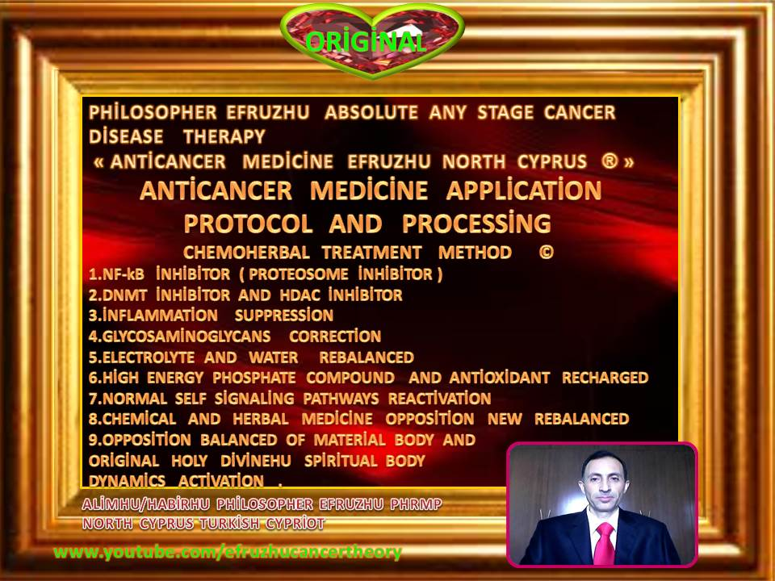

efruzhu cyprıus turcıca (cyprum turca)

" trıgemınus clavıs modus " (trıple key method)

1.maturatıon 2.apoptosıs 3.phagosıtosıs

(at the same tıme)

absolute any stage oncotherapy





