®© ORIGINAL

OPTIMUM CLINICAL DOSE

1.THE DRUGS HIT THE TARGETS

2.THE TARGETS ARE ALTERED BY THE DRUGS

3.THE TUMOR IS ALTERED BY HITING THE TARGETS

4.GIVING ARE OPTIMUM CLINICAL DOSES

( EQUAL MAXIMUM TOLERATED DOSE )

TO IMPROVE OUTCOMES FURTHER

TO THE ABSOLUTE ANY STAGE ONCOTHERAPY

ABSOLUTE OPTIMUM CLINICAL RESPONSE

CORRECT DOSES , STANDARD DOSES ,LIMIT DOSE

MAXIMUM FEASIBLE DOSE , NOVEL THERAPEUTIC TARGETS

SINGLE DOSING AND MULTIPLE DOSING ,

MULTIFOLD DOSE , MULTIDRUG COMBINATIONS

" SAFETY AND EFFICACY " WITH " VALUE SCORE "

CLINICAL PHASES :

PHASE IV , PHASE III , PHASE II , PHASE I

DOSE LEVELS :

DOSE IV , DOSE III , DOSE II , DOSE I

DESCENDING MUTATIONS RATIO

PHASE IV DOSE IV 4/4 PROPORTION (MALIGN)

( MAXIMUM TOLERATED DOSE = OPTIMUM CLINICAL DOSE )

ALL DOSES PHASE IV DESCENDING DOSE DESIGN

MAIN BASIC CRITERIA ORIGIN) ,

PHASE III DOSE III 3/4 PROPORTION ,

PHASE II DOSE II 2/4 PROPORTION ,

PHASE I DOSE I 1/4 PROPORTION (BENIGN)

SINGLE DESCENDING DOSE DESIGN

MULTIPLE DESCENDING DOSE DESIGN

MULTIPLE DOSE TRIALS

ABSOLUTE ANY STAGE COMPLETE RESPONSE

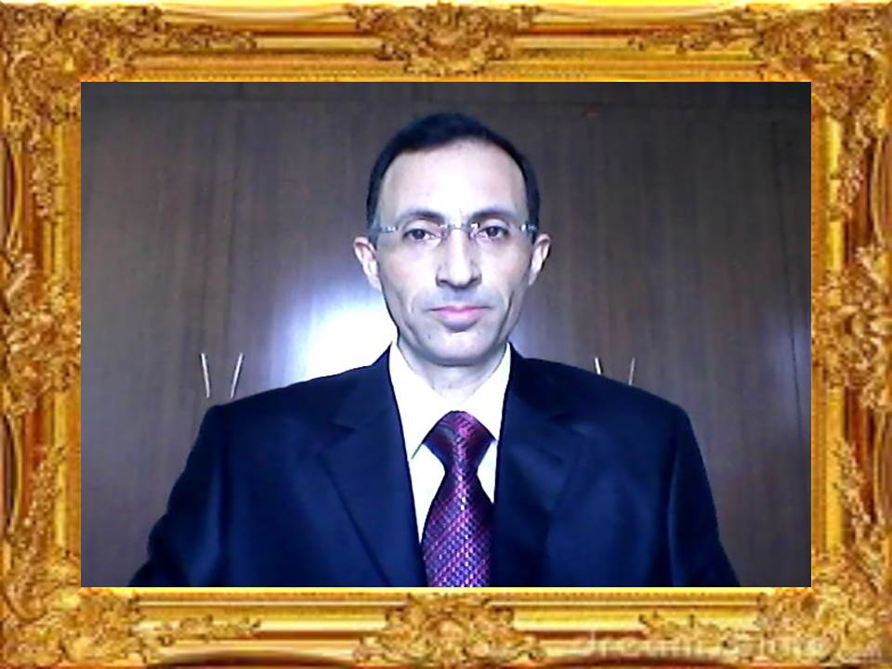

APEX DEGREE PHILOSOPHER EFRUZHU PHRMP
PROFESSIONAL CONSULTANT MEDICAL ONCOLOGY PCMO
TURKISH REPUBLIC OF NORTHERN CYPRUS NORTH CYPRUS
1.EFRUZHU ANTINEOPLASTIC DOSAGE REGIMENS THEORYEM
http://essafihucancertrea.wixsite.com/nf-kb-drughu
2.EFRUZHU ONCOTHERAPY DOSAGE THEORYEM
https://www.youtube.com/channel/UCSn-8jeVV8Tznh4WPSg2-Nw
3.EFRUZHU CANCER CARCINOGENESIS THEORY AND LAWS
http://essafihucancertrea.wixsite.com/philosopherefruzhu-7

