EFRUZHU CLINICAL ONCOLOGY
ABSOLUTE ANY STAGE THERAPEUTIC
DESCENDING DOSE DESIGN MODEL

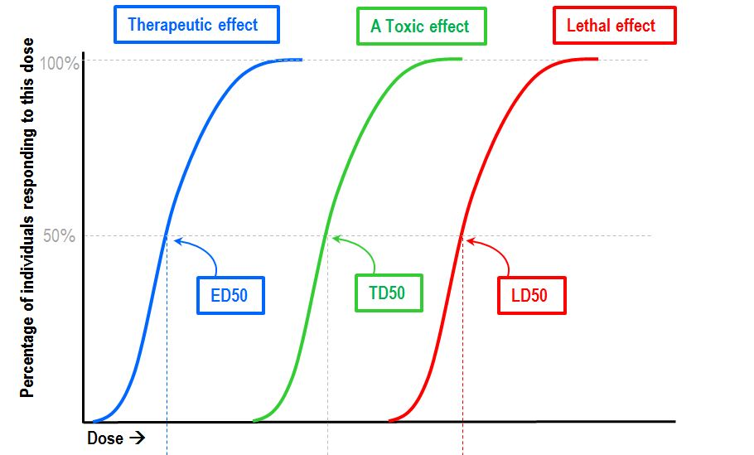
P4 MTD 4/4
P3 MTD 3/4
P1 MTD 1/4
P2 MTD 2/4

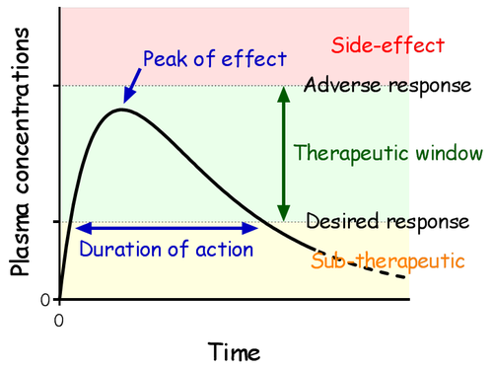
P4

P3

P2

P1

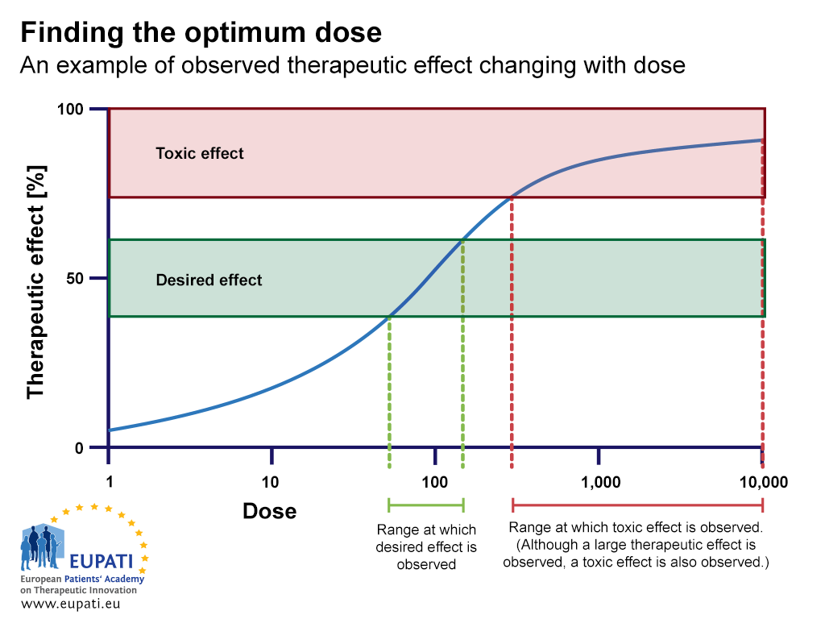
DESCENDING
DOSE DESIGN
MTD P4
P3 MTD
P2 MTD
P1 MTD

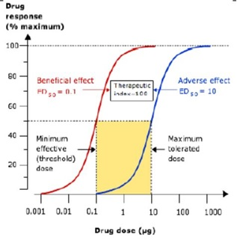
MTD %100 1/4

MTD %100 3/4

MTD %100 2/4

MTD %100 4/4
BSA:BODY SURFACE AREA FOR MTD
ADULT 2.20 – 2.80 SQUARE METERS M2
PEDIATRIC O.49 – 1.30 SQUARE METERS M2

P4

P3

P2

P1

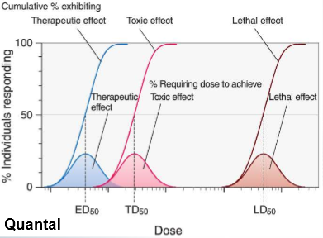

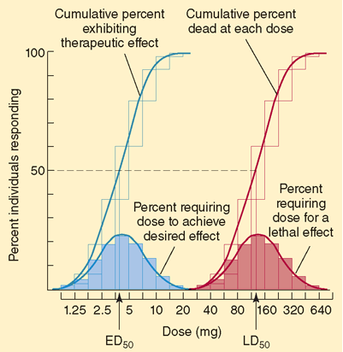
P4 BASED STANDART 4/4=1

MTD

MTD

MTD

MTD
P1=1/4 = 0.25
P2=2/4 =0.50
P3 =3/4 = 0.75
DESCENDİNG

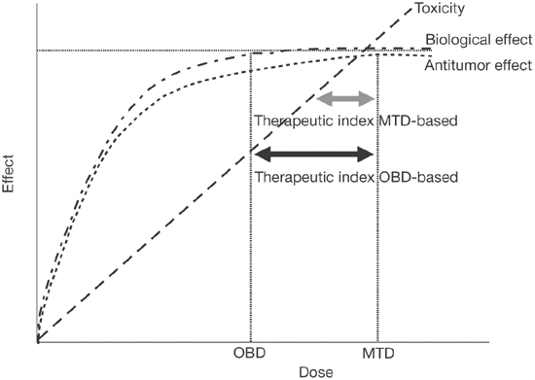

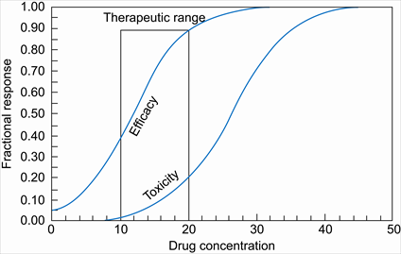

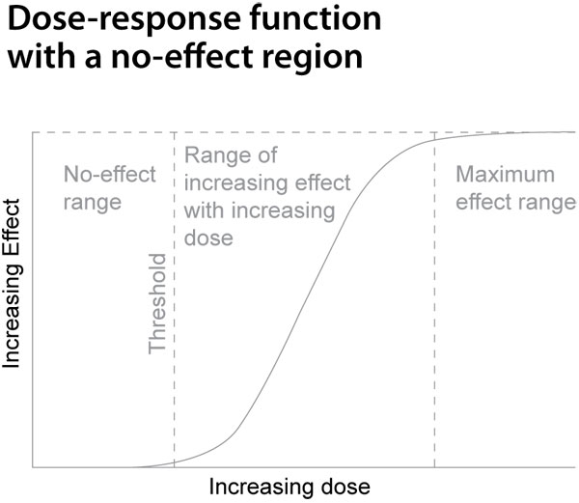
P2
P1
P3
P4

ABSOLUTE ANY STAGE ONCOTHERAPY

MAXIMUM TOLERATED DOSE = MAXIMAL CLINICAL RESPONSE DOSE
INDEPENDENT CONSTANT - STABLE
GENETICS AND ENVIRONMENTAL UNCERTAINITY FACTORS
EQUAL CONSTANT - STABLE
FENOTYPIC UNCERTAINITY FACTORS SO THAT
ABSOLUTELY DEPENDENCE
ABSOLUTE MAXIMAL TOLERATED DOSE MTD
AND
ABSOLUTE THERAPEUTIC REAL MAIN ESSENTIAL CANCER
MECHANISMS WHICH POSSIBLE
- “EFRUZHU CYPRIUS TURCICA TRIGEMINUS CLAVIS MODUS”
( EFRUZHU TRIPLE KEY METHOD MECHANISMS )
(MATURATION , APOPTOSIS , PHAGOSITOSIS AT THE SAME TIME)
AND
2.“EFRUZHU CLINICAL ONCOLOGY DESCENDING DOSE DESIGN MODEL”
THAT BASED STANDARD IS
PHASE 4 DOSE 4 4/4 1.0 MTD THEN
DERIVED OTHERS FROM PHASE 4
PHASE 3 DOSE 3 3/4 0.75 MTD
PHASE 2 DOSE 2 2/4 0.50 MTD
PHASE 1 DOSE 1 1/4 0.25 MTD
FROM MALIGN TO THE BENIGN WHICH EVERY PHASE EXISTENCE
ABSOLUTE SOLUTION :
1. ABSOLUTE CANCER THERAPEUTIC MECHANISMS
2. MAXIMAL TOLERATED DOSE = MAXIMAL CLINICAL RESPONSE DOSE

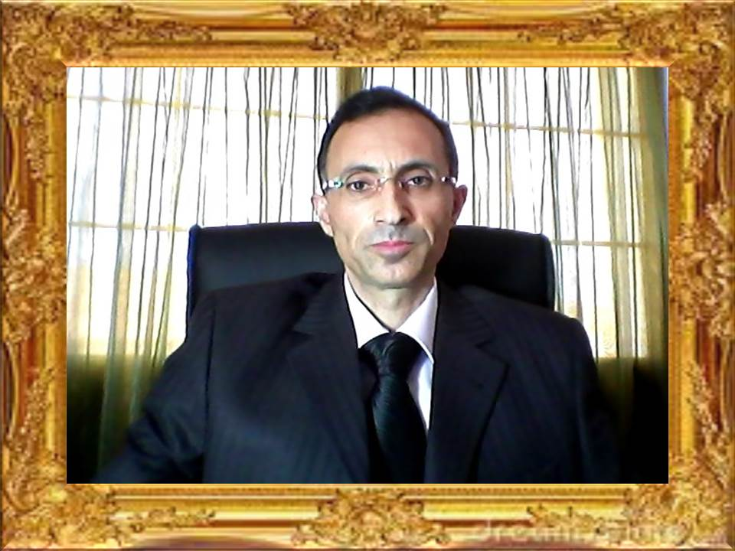

APEX DEGREE
TURKISH CYPRIOT PHILOSOPHER EFRUZHU PHRMP
PROFESSIONAL
CONSULTANT MEDICAL ONCOLOGY PCMO
TURKISH REPUBLIC OF NORTHERN CYPRUS NORTH CYPRUS

1.EFRUZHU ANTINEOPLASTIC DOSAGE REGIMENS THEORYEM
http://essafihucancertrea.wixsite.com/nf-kb-drughu

2.EFRUZHU ONCOTHERAPY DOSAGE THEORYEM
https://www.youtube.com/channel/UCSn-8jeVV8Tznh4WPSg2-Nw

3.EFRUZHU CANCER CARCINOGENESIS
THEORY AND LAWS
http://essafihucancertrea.wixsite.com/philosopherefruzhu-7

4.ALL-IN-ONE SITE SYSTEM
https://essafihucancertrea.wixsite.com/allahahadvitrferdhu1

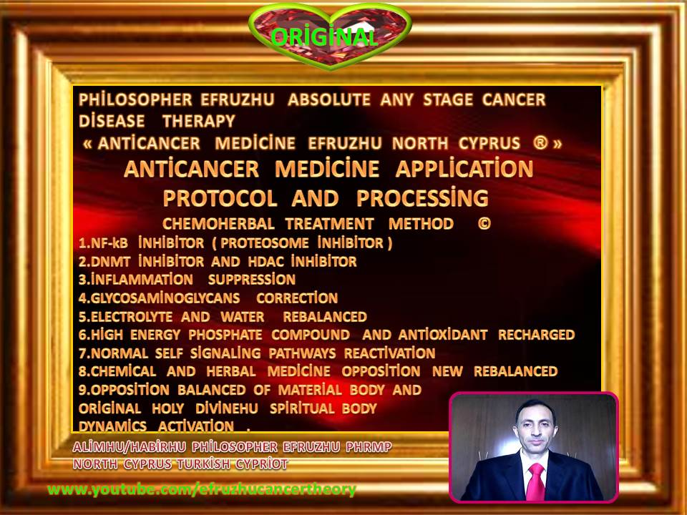

efruzhu cyprıus turcıca (cyprum turca)

“trıgemınus clavıs modus " (trıple key method)

1.maturatıon

2.apoptosıs

3.phagosıtosıs

(at the same tıme)

absolute any stage

oncotherapy

EFRUZHU ONCOMEDICUS LAWS

1. ALL OF THE CANCER TYPES NEED TO NORMAL AND MUTATIONS DYNAMICS OPPOSITION BALANCED WITH SHARING CODOMINANT (EQUALLY DOMINANT ) FUNCTIONALITY.
2. FEEDBACK MECHANISMS HAD BEEN FORMATED BETWEEN NORMAL IDENTITY AND MUTATIONS IDENTITY .
3. MAIN ESSENTIAL THERAPEUTIC DRUGS : NF-Kb + ANTIINFLAMMATION FOR MUTATIONS IDENTITY. HDAC + DNMT + GLYCOSAMINOGLYCAN + ELECTROLYTE + SIGNALING + HOLY DIVINEHU FOR NORMAL IDENTITY .
4. THERAPEUTIC STYLE HAD BEEN ESTABLISHED CONVENTIONAL AND UNCONVENTIONAL ( HERBAL-NATURAL ) DRUGS
5. TRETMENT METHOD IS TRIPLE KEY METHOD ( TRIGEMINUS CLAVIS MODUS ) MATURATION,APOPTOSIS,PHAGOSITOSIS AT THE SAME TIME .
6. HOLY DIVINEHU SPIRITUAL ACTIVATION FOR SPIRITUAL AND MATERIAL BODIES OPPOSITION BALANCED .

®© ORIGINAL

ABSOLUTE ANY STAGE OPTIMUM CLINICAL RESPONSE DOSE

1.THE DRUGS HIT THE TARGETS FOR MULTIPLE MECHANISMS

2.THE TARGETS ARE ALTERED BY THE DRUGS WİTH CONVENTIONAL AND UNCONVENTIONAL NATURAL OPPOSITION BALANCE AND THEIRS DYNAMICS

3.THE TUMOR IS ALTERED TO THE MATURATION,APOPTOSIS,PHAGOSITOSIS AT THE SAME TIME BY HITING THE DRUGS VIA THE TARGETS MULTIPLE MECHANISMS

4.GIVING ARE OPTIMUM CLINICAL RESPONSE DOSES (EQUAL MAXIMUM TOLERATED DOSE) TO IMPROVE OUTCOMES FURTHER TO THE ABSOLUTE ANY STAGE ONCOTHERAPY

