



EFRUZHU PROGNOSTIC MARKERS
THEOREM AND ADVOCATES
© ®
NORTH CYPRUS TURKISH CYPRIOT
1.MOLECULAR GENETIC OF WILD NORMAL GENES HYPERMETHYLATION RATE
2.MOLECULAR PATHOLOGICAL GENES MUTATIONS / CHROMOSOMAL ABERRATIONS RATE
3.HISTOPATHOLOGICAL GRADES RATE
4.CLINICAL REGIONAL / DISTANT METASTASES RATE
5.BIOCHEMICAL AND MOLECULAR BIOLOGY MULTIPLE PARAMETERS EVALUATION RATE
6.IMMUNOHISTOCHEMISTRY PARAMETERS RATE
7.CLINICAL STAGE EXAMINATION OF DISEASE / PATIENTS VITAL PARAMETERS RATE
8.LOSS OF WILD ALLELES (LOSS OF HETEROZIGOSITY) RATE
9.CHROMOSOMAL EUPLOID / DIPLOID RATE



EFRUZHU ANTICANCER /ANTINEOPLASTIC
DRUG RESISTANCE
THEOREM AND ADVOCATES
© ®
NORTH CYPRUS TURKISH CYPRIOT

1.MOLECULAR ENERGY METABOLISM RATE
2.MUTATIONS RECEPTORS - CHANNELOPATHY RATE
3.CLINICAL STAGE OF DISEASE / PATIENTS
4.WILD NORMAL DNA GENES HYPERMETHYLATION / HYPOMETHYLATION RATE
5.LOSS OF WILD NORMAL ALLELES RATE
6.MOLECULAR OXIDANT / ANTIOXIDANT RATE
7.PROINFLAMMATORY / INFLAMMATION GROWTH FACTORS , CYTOKINES RATE
8.SUCCESFUL MOLECULAR AND CELLULAR PHAGOSITOSIS ,APOPTOSIS , MATURATION , MULTIPLE OPPOSITES BALANCED RATE
9.SOMATIC AND PSYCHOLOGICAL OPPOSITES BALANCED RATE



UNIQUE “ MGSM ” OF ALL CANCERS ONE CLASSIFICATION © ®
EFRUZHU NORTH CYPRUS (TURKISH CYPRIOT)
CLINICAL MEDICAL ONCOLOGY STAGING SYSTEM

MOLECULAR GENETIC HISTOPATHOLOGY STAGE METASTASES

M1 G1 S1 M1
M2 G2 S2
M3 G3 S3 M2
M4 G4 S4

M1:% 0 – 25 TOTAL WILD DNA MUTATIONS PROPORTION
M2:% 26 – 50 TOTAL WILD DNA MUTATIONS PROPORTION
M3:% 51 – 75 TOTAL WILD DNA MUTATIONS PROPORTION
M4:% 76 – 100 TOTAL WILD DNA MUTATIONS PROPORTION

G1:GRADE 1 WELL DİFFERENTIATED
G2:GRADE 2 MODERATELY DİFFERENTIATED
G3:GRADE 3 POORLY DIFFERENTIATED
G4:GRADE 4 UNDIFFERENTIATED

S1:CLINICAL STAGE DISEASE/PATIENTS
S2: CLINICAL STAGE DISEASE/PATIENTS
S3: CLINICAL STAGE DISEASE/PATIENTS
S4: CLINICAL STAGE DISEASE/PATIENTS

M1:LOCOREGIONAL-NEARBY (LOCAL REGIONAL) LYMPH NODES METASTASES
M2:DISTANT METASTASES
STAGING OF CLINICAL MEDICAL ONCOLOGY FIGURES:
1)MOLECULAR FIGURE 2)PATHOLOGIC FIGURE 3)CLINICAL FIGURE 4)CLINICAL TRIAL FIGURE



EFRUZHU METASTASIS THEOREM AND ADVOCATES
© ®
NORTH CYPRUS TURKISH CYPRIOT

1.INADEQUATE NUTRITION
2.INADEQUATE OXYGENATION
3.HIGHER MITOTIC ACTIVITY
4.HIGHER MUTATIONAL MOLECULAR AND CELLULAR METABOLIC ACTIVITY
5.HIGHER WASTE PRODUCTS
6.HIGHER OXIDATIVE METABOLIC STRESS
7.LOWER ANTIOXIDANT QUANTITIES
8.LOWER AEROBIC GLYCOLYSIS / TCA (KREBS CYCLE)
9.HIGHER MUTATIONAL GENES DESTRUCTIVE / ANGIOGENIC / ANTISTABILIZATOR FACTORS ACTIVITY

EFRUZHU ONCOMEDICUS LAWS
1. ALL OF THE CANCER TYPES NEED TO NORMAL AND MUTATIONS DYNAMICS OPPOSITION BALANCED WITH SHARING CODOMINANT (EQUALLY DOMINANT ) FUNCTIONALITY.
2. FEEDBACK MECHANISMS HAD BEEN FORMATED BETWEEN NORMAL IDENTITY AND MUTATIONS IDENTITY .
3. MAIN ESSENTIAL THERAPEUTIC DRUGS : NF-Kb + ANTIINFLAMMATION FOR MUTATIONS IDENTITY. HDAC + DNMT + GLYCOSAMINOGLYCAN + ELECTROLYTE + SIGNALING + HOLY DIVINEHU FOR NORMAL IDENTITY .
4. THERAPEUTIC STYLE HAD BEEN ESTABLISHED CONVENTIONAL AND UNCONVENTIONAL ( HERBAL-NATURAL ) DRUGS
5. TRETMENT METHOD IS TRIPLE KEY METHOD ( TRIGEMINUS CLAVIS MODUS ) MATURATION,APOPTOSIS,PHAGOSITOSIS AT THE SAME TIME .
6. HOLY DIVINEHU SPIRITUAL ACTIVATION FOR SPIRITUAL AND MATERIAL BODIES OPPOSITION BALANCED .

EFRUZHU ONCOMEDICUS FORMULAE
NF-kB INHIBITOR : M1 ANTIINFLAMMATION : M2 HDAC INHIBITOR : N1 DNMT INHIBITOR : N2 GLYCOSAMINOGLYCAN : N3 ELECTROLYTE : N4 SIGNALING : N5 HOLY DIVINEHU : N6 M : MUTATIONS DYNAMICS DRUGS N : NORMAL DYNAMICS DRUGS

ABSOLUTE ANY STAGE ONCOTHERAPY :OT

1.)
N1+N2+N3+N4+N5+N6
OT = ----------------------------------------
M1+M2

2.)
OT: N1+N2+N3+N4+N5+N6—(M1+M2)

3.) OT: N1XN2XN3XN4XN5XN6—(M1XM2)

4.)
OT: N1+N2+N3+N4+N5+N6 = M1+M2= 0
5.)
OT: N1XN2XN3XN4XN5XN6 = M1XM2= 0



APEX DEGREE
TURKISH CYPRIOT PHILOSOPHER EFRUZHU PHRMP
PROFESSIONAL
CONSULTANT MEDICAL ONCOLOGY PCMO
TURKISH REPUBLIC OF NORTHERN CYPRUS NORTH CYPRUS
1.EFRUZHU ANTINEOPLASTIC DOSAGE REGIMENS THEORYEM
http://essafihucancertrea.wixsite.com/nf-kb-drughu

3.EFRUZHU CANCER CARCINOGENESIS
THEORY AND LAWS

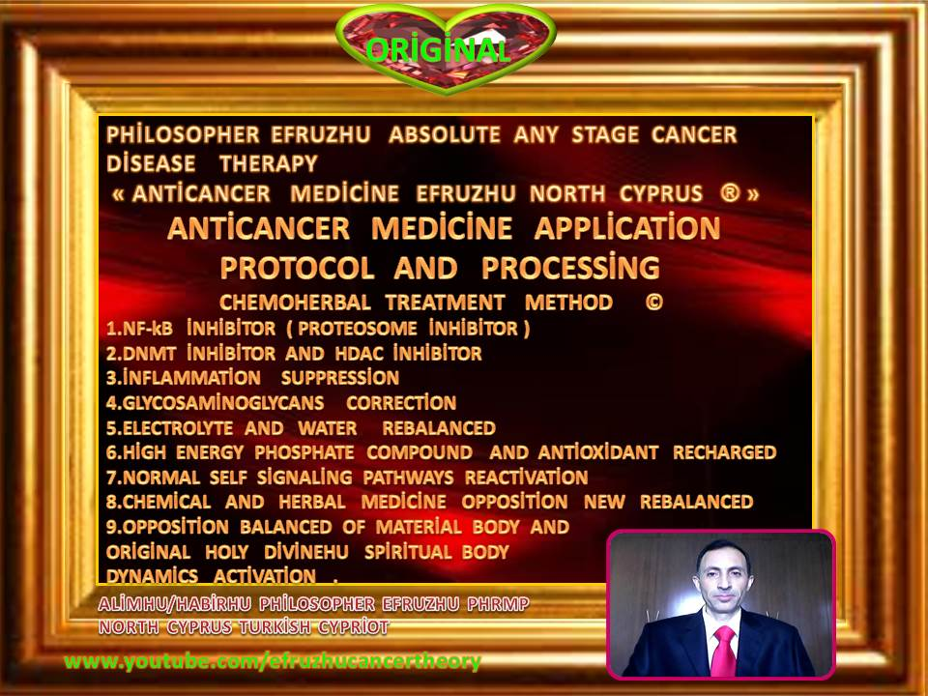

efruzhu cyprıus turcıca (cyprum turca)

“trıgemınus clavıs modus " (trıple key method)

1.maturatıon

2.apoptosıs

3.phagosıtosıs

(at the same tıme)

absolute any stage oncotherapy



efruzhu cyprıus turcıca (cyprum turca)

" trıgemınus clavıs modus " (trıple key method)

1.maturatıon 2.apoptosıs 3.phagosıtosıs

(at the same tıme)

absolute any stage oncotherapy

formulae ® ©

ONCOTHERAPY : OT

HDAC +DNMT ınhıbıtor actıvıty
- OT =-------------------------------------------------
NF-kb ınhıbıtor actıvıty

- ot=hdac + dnmt – nf-kb

hdac x dnmt ınhıbıtor actıvıty
- ot =------------------------------------------------------
nf-kb ınhıbıtor actıvıty





EFRUZHU RECURRENCE/RELAPSE
THEOREM AND ADVOCATES
© ®
NORTH CYPRUS TURKISH CYPRIOT

1.HIGHER NF-KB actıvıty
2.hypermethylatıon of normal wıld dna genes
3.chronıc ınflammatıon
4.hıgher growth factors , cytokınes , proınflammatorıal stımulatıon
5.ınadequate energy
6.normal wıld dna hıstones modıfıcatıons suppressıon
7.loss of heterozygosıty
8.ıncreasıng mutatıons and decreasıng wıld normal genes cellular governıng actıvıty
9.strong / hıgher oxıdant actıvıty



EFRUZHU SURVIVAL OUTCOMES
THEOREM AND ADVOCATES
© ®
NORTH CYPRUS TURKISH CYPRIOT
1.NEOPLASTIC TRANSFORMATIONS OF BENIGN - MALIGN RATE
2.WILD NORMAL DNA GENES SUCCESSFUL EXPRESSION RATE
3.CLINICAL DISEASE / PATIENTS RECURRENCE – RELAPS REGIONAL / DISTANT RATE
4.MOLECULAR GENETIC STABILITY – INSTABILITY RATE
5.ORGANS AND TISSUES PATHOLOGICAL ABNORMALITY RATE
6.WILD ALLELIC LOSS AND MUTATIONS , CHROMOSOMAL ABERRATIONS RATE
7.REGIONAL / DISTANT METASTASES RATE
8.ANTICANCER – ANTINEOPLASTIC DRUG TREATMENT –THERAPY REMISSION RATE
9.PROGNOSTIC SIGNIFICANCE INDICATOR / MARKER / VALUES RATE

EFRUZHU NORTH CYPRUS (TURKISH CYPRIOT) ®©
MOLECULAR AND CELLULAR & CLINICAL MEDICAL ONCOLOGY PRINCIPLES/FORMULAE

SURVIVAL , METASTASIS , RECURRENSIS , PROGNOSIS

$$X=\frac{DIRECTLY PROPORTIONAL}{INVERSELY PROPORTIONAL}$$

$$ENERGY=\frac{HYPOMETHYLATION GENES EXPRESSION}{HYPERMETHYLATION GENES SILENCED}$$

$$ENERGY=\frac{MUTATIONS GENES EXPRESSION }{WILD ALLELES LOSS (LOSS OF HETEROZYGOSITY)}$$

$$APOPTOSIS (PROGRAMMED CELL DEATH)=\frac{ENERGY DEGREE}{MUTATIONS GENES DEGREE}$$

$$ANTINEOPLASTIC-ANTICANCER DRUG RESISTANCE=\frac{MUTATIONS GENES RECEPTORS RATE}{ENERGY RATE}$$

$$MALIGNITY DEGREE=\frac{MUTATIONS DEGREE}{ENERGY DEGREE}$$

CANCER THERAPY SURVIVAL DEGREE =APOPTOSIS +PHAGOSITOSIS + MULTIPLE OPPOSITES BALANCED + MATURATION AT THE SAME TIME

$$MALIGN CANCER CELL=\frac{ANAEROBIC GLYCOLYSIS ENERGY RATE}{AEROBIC+TCA CYCLE ENERGY RATE}$$

$$BENIGN NEOPLASTIC CELL=\frac{AEROBIC GLYCOLYSIS+TCA CYCLE ENERGY RATE}{ANAEROBIC GLYCOLYSIS ENERGY RATE}$$

RECURRENS RELAPS FORMULAE=
EFRUZHU MOLECULAR AND CELLULAR CARCINOGENESIS LAWS
1.MUTATIONS GROUP IDENTITY 2.INADEQUATE ENERGY 3.CHRONIC INFLAMMATION 4.NORMAL WILD DNA SUPPRESSION +GROWTH FACTORS +CYTOKINES +NF-Kb +HYPOOXYGENATION +INADEQUATE NUTRITION.

$$SURVIVAL RATE/OVERCOME=\frac{CHROMOSOMAL ABERRATIONS DEGREE}{WILD CHROMOSOMAL DEGREE}$$

OR

$$SURVIVAL RATE/DEGREE=\frac{MUTATIONS GENES DEGREE}{WILD \frac{GENES}{ALLELES} DEGREE}$$

$$APOPTOSIS=\frac{\frac{ENERGY}{WILD GENES ALLELES} DEGREE}{NF-kB DEGREE}$$

$$SURVIVAL RATE=\frac{DIPLOID RATE}{ANEUPLOID RATE}$$

$$MALIGNITY DEGREE=\frac{ANEUPLOID DEGREE}{DIPLOID DEGREE}$$

LOSS OF HETEROZYGOSITY SURVIVAL RATE DECREASING,NO LOSS WITHOUT HETEROZYGOSITY SURVIVAL RATE INCREASING

$$SURVIVAL RATE=\frac{EXISTANCE PHYSIOLOGIC BALANCED RATE}{LOST OF HOMEOSTATIC BALANCED RATE}$$

OR

$$SURVIVAL RATE=\frac{MOLECULAR GENETIC STABILITY RATE }{PATHOLOGICAL ABNORMALITY RATE}$$

HIGHER OF RECURRENCE PARALLEL OF METASTASIS,HIGHER RISK OF METASTASIS PARALLEL OF HIGHER MITOTIC COUNT / ACTIVITY ALSO RECURRENCE,CONTRARY LOW MITOTIC COUNT /ACTIVITY WITHOUT /NO PARALLEL THE POSSIBILITY OF METASTASIS.
WILD ALLELIC LOSS AND MUTATIONS EQUAL WILD DNA GENETIC INSTABILITY , ABERRATIONS , GENETIC ABNORMALITY.

SURVİVAL OUTCOMES:
1.MALIGNITY DEGREE 2.MUTATIONS DEGREE 3.CHROMOSOMAL ABNORMALITY (ANEUPLOIDY/ABERRATIONS DEGREE) 4.ENERGY MAIN WAYS (AEROBIC/UNAEROBIC GLYCOLYSIS AND TCA/KREBS CYCLE DEGREE 5.HOMEOSTATIC BALANCED IMBALANCED OF ALL VITAL PARAMETERS DEGREE 6.NODAL INVOLMENT DEGREE 7.METASTASES 8.RECURRENCES 9.SPIRITUAL COGNITIVE DYNAMICS DISTURBANCES RATE

HOMEOSTATIC BALANCED DEPENDENCE OF MALIGNITY DEGREE THAT PARALLEL OF ACIDS DEGREE

METASTASIS DEPENDENCE:
OXYGEN RATE
NUTRITION RATE
HIGHER MITOTIC ACTIVITY RATE
WASTE PRODUCTS RATE
STABILITY-INSTABILITY CONDITIONS/DYNAMICS/FACTORS RATE



EFRUZHU PROGNOSIS THEOREM AND ADVOCATES
© ®
NORTH CYPRUS TURKISH CYPRIOT
1.CHROMOSOMAL ABERRATIONS RATE
2.GENES MUTATIONS RATE
3.MOLECULAR / CLINICAL PATHOLOGICAL CONDITIONS RATE
4.ANTINEOPLASTIC – ANTICANCER DRUG RESISTANCE RATE
5.ORGAN SYSTEMS AND TISSUES HOMEOSTATIC PHYSIOLOGIC BALANCED RATE
6.VITAL PARAMETERS REFERENCE VALUES OPTIMAL RATE
7.SOMATIC BODY AND SPIRITUAL - PSYCHOLOGICAL BODY NUTRITIONAL RATE
8.METABOLIC / MOLECULAR GENETIC TOXICATION RATE
9.CLINICAL STAGE OF DISEASE / PATIENTS RATE

