EFRUZHU ONCOMEDICUS LAWS
1. ALL OF THE CANCER TYPES NEED TO NORMAL AND MUTATIONS DYNAMICS OPPOSITION BALANCED WITH SHARING CODOMINANT (EQUALLY DOMINANT ) FUNCTIONALITY.
2. FEEDBACK MECHANISMS HAD BEEN FORMATED BETWEEN NORMAL IDENTITY AND MUTATIONS IDENTITY .
3. MAIN ESSENTIAL THERAPEUTIC DRUGS : NF-Kb + ANTIINFLAMMATION FOR MUTATIONS IDENTITY. HDAC + DNMT + GLYCOSAMINOGLYCAN + ELECTROLYTE + SIGNALING + HOLY DIVINEHU FOR NORMAL IDENTITY .
4. THERAPEUTIC STYLE HAD BEEN ESTABLISHED CONVENTIONAL AND UNCONVENTIONAL ( HERBAL-NATURAL ) DRUGS
5. TRETMENT METHOD IS TRIPLE KEY METHOD ( TRIGEMINUS CLAVIS MODUS ) MATURATION,APOPTOSIS,PHAGOSITOSIS AT THE SAME TIME .
6. HOLY DIVINEHU SPIRITUAL ACTIVATION FOR SPIRITUAL AND MATERIAL BODIES OPPOSITION BALANCED .

EFRUZHU ONCOMEDICUS FORMULAE
NF-kB INHIBITOR : M1 ANTIINFLAMMATION : M2 HDAC INHIBITOR : N1 DNMT INHIBITOR : N2 GLYCOSAMINOGLYCAN : N3 ELECTROLYTE : N4 SIGNALING : N5 HOLY DIVINEHU : N6 M : MUTATIONS DYNAMICS DRUGS N : NORMAL DYNAMICS DRUGS

ABSOLUTE ANY STAGE ONCOTHERAPY :OT

1.)
N1+N2+N3+N4+N5+N6
OT = ----------------------------------------
M1+M2

2.)
OT: N1+N2+N3+N4+N5+N6—(M1+M2)

3.) OT: N1XN2XN3XN4XN5XN6—(M1XM2)

4.)
OT: N1+N2+N3+N4+N5+N6 = M1+M2= 0
5.)
OT: N1XN2XN3XN4XN5XN6 = M1XM2= 0
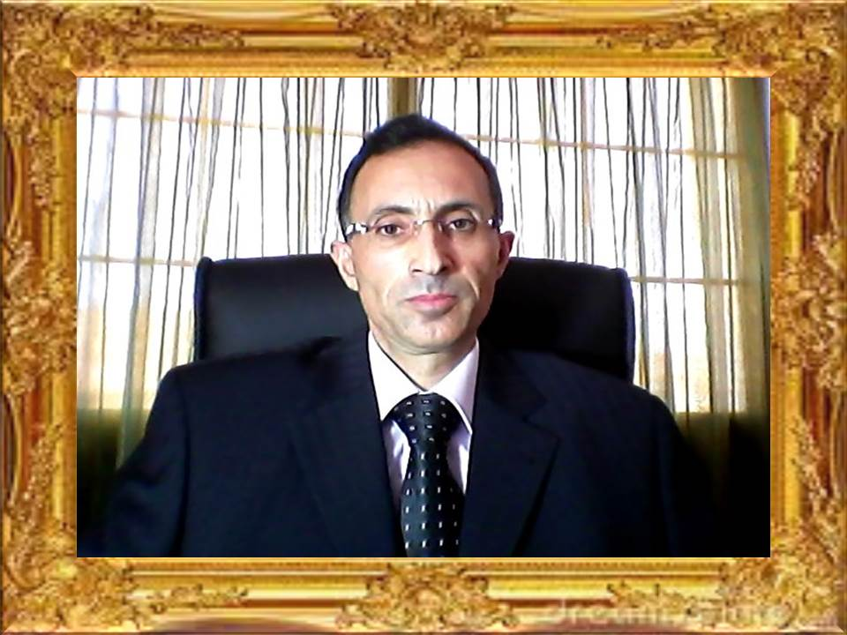
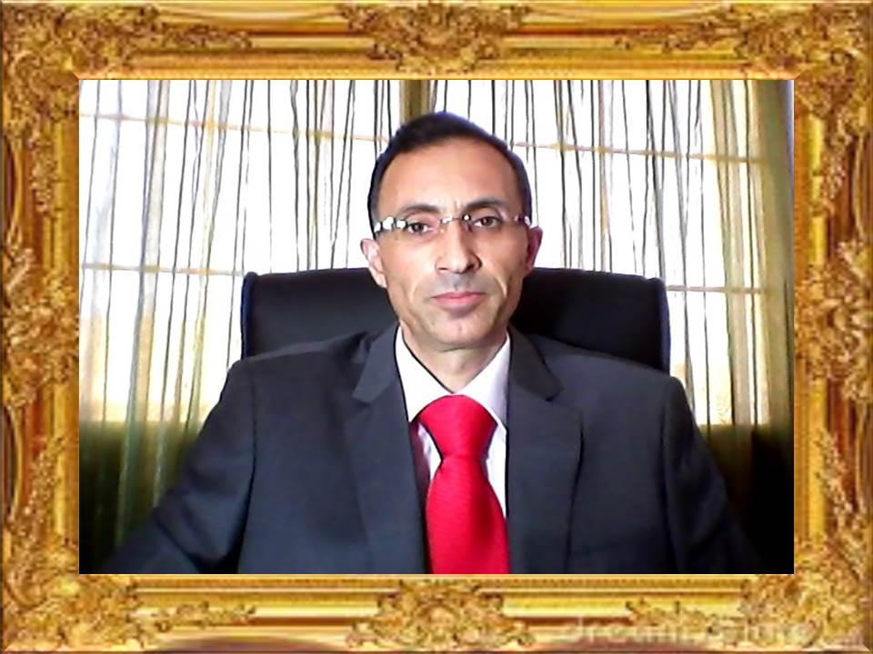

APEX DEGREE
TURKISH CYPRIOT PHILOSOPHER EFRUZHU PHRMP
PROFESSIONAL
CONSULTANT MEDICAL ONCOLOGY PCMO
TURKISH REPUBLIC OF NORTHERN CYPRUS NORTH CYPRUS
1.EFRUZHU ANTINEOPLASTIC DOSAGE REGIMENS THEORYEM
http://essafihucancertrea.wixsite.com/nf-kb-drughu

2.EFRUZHU ONCOTHERAPY DOSAGE THEORYEM
https://www.youtube.com/channel/UCSn-8jeVV8Tznh4WPSg2-Nw

3.EFRUZHU CANCER CARCINOGENESIS
THEORY AND LAWS
http://essafihucancertrea.wixsite.com/philosopherefruzhu-7

4.ALL-IN-ONE SITE SYSTEM
https://essafihucancertrea.wixsite.com/allahahadvitrferdhu1

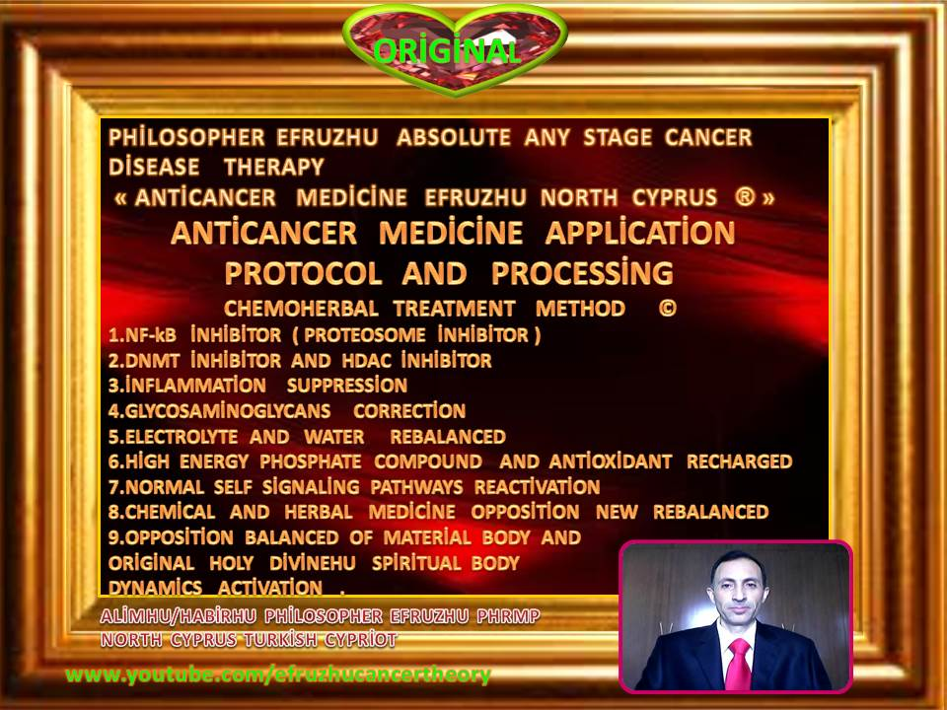

efruzhu cyprıus turcıca (cyprum turca)

“trıgemınus clavıs modus " (trıple key method)

1.maturatıon

2.apoptosıs

3.phagosıtosıs

(at the same tıme)

absolute any stage oncotherapy

