®©
“ EFRUZHU DESCENDING DOSE DESIGN MODEL “
“EFRUZHU DESCENDO DOSE DESIGNO EXEMPLUM”
MAXIMUM TOLERATED DOSE = OPTIMUM CLINICAL RESPONSE DOSE

INDEPENDENT OF GENETICS AND ENVIRONMENTAL FACTORS
AS UNCERTAINITY
FACTORS , DYNAMICS MEANS
MAXIMUM TOLERATED DOSE (MTD) =
OPTIMUM CLINICAL RESPONSE DOSE =
TOXIC DOSE 50 (TD50) = EFFECTIVE DOSE 50 (ED50) = 1
FOR PHASE 1 , PHASE 2 ,
PHASE 3 , PHASE 4 SPECIFICALLY SEPERATELY
FOR ABSOLUTE ANY STAGE ONCOTHERAPY.
ALL OF THE ABSOLUTE THERAPEUTIC TARGETS MECHANISMS = STABLE – CONSTANT
OF GENETICS AND ENVIRONMENTAL UNCERTAINITY FACTORS WITH EFRUZHU CYPRIUS TURCICA “TRIGEMINUS CLAVIS MODUS”=”TRIPLE KEY METHOD” AND PRACTICALLY “ EFRUZHU DESCENDING DOSE DESIGN MODEL ”

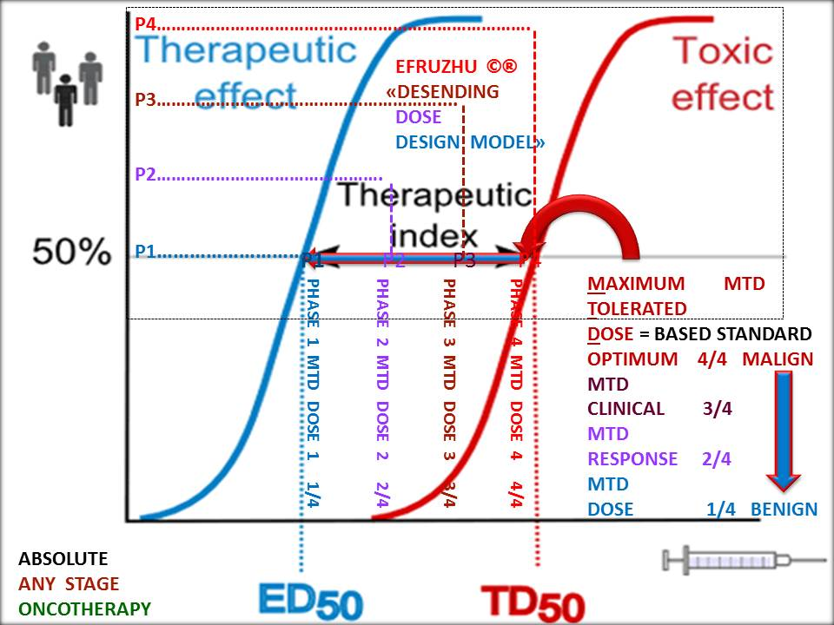

ABSOLUTE OPTIMUM CLINICAL
RESPONSE DOSE
CORRECT DOSES , STANDARD DOSES, LIMIT DOSE
MAXIMUM FEASIBLE DOSE , NOVEL THERAPEUTIC TARGETS
SINGLE DOSING AND MULTIPLE DOSING ,
MULTIFOLD DOSE , MULTIDRUG COMBINATIONS
" SAFETY AND EFFICACY " WITH " VALUE SCORE "
CLINICAL PHASES :
PHASE IV , PHASE III , PHASE II , PHASE I
DOSE LEVELS :
DOSE IV , DOSE III , DOSE II , DOSE I

PHASE IV DOSE IV 4/4 PROPORTION (MALIGN)
( MAXIMUM TOLERATED DOSE = OPTIMUM CLINICAL DOSE )

DESCENDING MUTATIONS RATIO
ALL DOSES PHASE IV BASED STANDARD
“EFRUZHU DESCENDING DOSE DESIGN MODEL ” ®©
MAIN BASIC CRITERIA ORIGIN) ,
PHASE III DOSE III 3/4 PROPORTION ,
PHASE II DOSE II 2/4 PROPORTION ,
PHASE I DOSE I 1/4 PROPORTION(BENIGN)
SINGLE DESCENDING DOSE DESIGN
MULTIPLE DESCENDING DOSE DESIGN
MULTIPLE DOSE TRIALS
ABSOLUTE ANY STAGE COMPLETE RESPONSE



APEX DEGREE
TURKISH CYPRIOT PHILOSOPHER EFRUZHU PHRMP
PROFESSIONAL
CONSULTANT MEDICAL ONCOLOGY PCMO
TURKISH REPUBLIC OF NORTHERN CYPRUS NORTH CYPRUS
1.EFRUZHU ANTINEOPLASTIC DOSAGE REGIMENS THEORYEM
http://essafihucancertrea.wixsite.com/nf-kb-drughu

2.EFRUZHU ONCOTHERAPY DOSAGE THEORYEM
https://www.youtube.com/channel/UCSn-8jeVV8Tznh4WPSg2-Nw

3.EFRUZHU CANCER CARCINOGENESIS
THEORY AND LAWS
http://essafihucancertrea.wixsite.com/philosopherefruzhu-7

4.ALL-IN-ONE SITE SYSTEM
https://essafihucancertrea.wixsite.com/allahahadvitrferdhu1

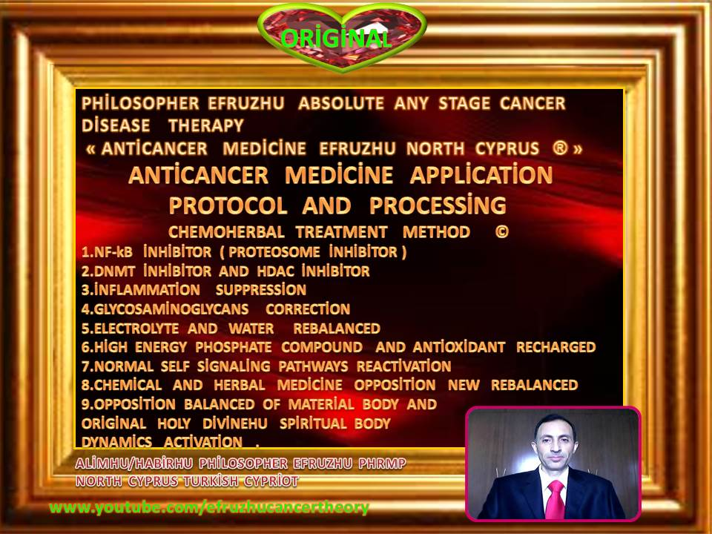

efruzhu cyprıus turcıca (cyprum turca)

“trıgemınus clavıs modus " (trıple key method)

1.maturatıon

2.apoptosıs

3.phagosıtosıs

(at the same tıme)

absolute any stage

oncotherapy

