® ©

ABSOLUTE ANY STAGE ONCOTHERAPY MAIN ESSENTIAL PODIAS:
1.MOLECULAR DRUG CHEMOONCOTHERAPY
2.CLINICAL MEDICAL DRUG CHEMOONCOTHERAPY
3.NATURAL DRUG ONCOTHERAPY
4.SPIRITUAL DRUG ONCOTHERAPY

A) EFRUZHU MEDICAL NEBEVİHU ONCOMEDICINE
THERAPEUTIC RECOMBINATION SCHEDULE 1
® ©

B) EFRUZHU ABSOLUTE ANY STAGE
ONCOTHERAPY FORMULAE ® ©

C) EFRUZHU
ABSOLUTE CLINICAL RESPONSE DOSE
PHILOSOPHY ® ©

D) EFRUZHU
ONCOMEDICUS LAWS AND FORMULAE ® ©

E) “ EFRUZHU DESCENDING DOSE DESIGN MODEL”
“EFRUZHU DESCENDO DOSE DESIGNO EXEMPLUM” ®©

F) EFRUZHU

CLINICAL ONCOLOGY

ABSOLUTE ANY STAGE THERAPEUTIC

DESCENDING DOSE DESIGN MODEL ®©

G) “NF-KB INHIBITORS”
efruzhu SEPTENTRIONALIS CYPRUM - cyprIus turcIca (cyprum turca)
" NORTH CYPRUS TURKISH CYPRIOT "
" QUATRUPLEX clavIs modus "
(QUATRUPLE-QUATERNARY key method)
1.maturatıon 2.apoptosIs 3.phagosItosIs 4.MULTIPLE OPPOSITES BALANCED
(at the same tIme)
absolute any stage oncotherapy ® ©

H)”HDAC-DNMT INHIBITORS”
efruzhu SEPTENTRIONALIS CYPRUM - cyprIus turcIca (cyprum turca)
" NORTH CYPRUS TURKISH CYPRIOT "
" QUATRUPLEX clavıs modus "
(QUATRUPLE-QUATERNARY key method)
1.maturatıon 2.apoptosıs 3.phagosıtosıs 4.MULTIPLE OPPOSITES BALANCED
(at the same tıme)
absolute any stage oncotherapy ® ©

I) EFRUZHU MEDICAL NEBEVİHU ONCOMEDICINE
THERAPEUTIC RECOMBINATION SCHEDULE “INFLAMMATION SUPRESSION” 3 ® ©

İ) EFRUZHU ABSOLUTE ANY STAGE ONCOTHERAPY FORMULAE
“INFLAMMATION SUPPRESSION” ® ©

J) EFRUZHU MEDICAL NEBEVIHU ONCOMEDICINE

THERAPEUTIC RECOMBINATION SCHEDULE 4
® ©

K) EFRUZHU MEDICAL NEBEVİHU ONCOMEDICINE

THERAPEUTIC RECOMBINATION SCHEDULE 5 ® ©

ELECTROLYTE AND WATER REBALANCED

L)”ELECTROLYTE” EFRUZHU ABSOLUTE ANY STAGE ONCOTHERAPY FORMULAE ® ©

M)”ENERGY AND ANTIOXIDANT RECHARGED ” EFRUZHU MEDICAL NEBEVİHU
ONCOMEDICINE
THERAPEUTIC RECOMBINATION
SCHEDULE 7 ® ©
N)”ENERGY” EFRUZHU ABSOLUTE ANY STAGE ONCOTHERAPY FORMULAE ® ©
O) EFRUZHU MEDICAL NEBEVİHU ONCOMEDICINE
THERAPEUTIC RECOMBINATION SCHEDULE 8 ® ©
SIGNALING REACTIVATION
Ö) EFRUZHU ABSOLUTE ANY STAGE ONCOTHERAPY FORMULAE SIGNALING ® ©
P) EFRUZHU MEDICAL NEBEVİHU
ONCOMEDICINE
THERAPEUTIC RECOMBINATION
SCHEDULE 9 ® ©
NATURAL HERBAL DRUGHU
R) EFRUZHU ABSOLUTE ANY STAGE ONCOTHERAPY FORMULAE NATURAL HERBAL DRUGHU ® ©
S) EFRUZHU MEDICAL NEBEVİHU ONCOMEDICINE
THERAPEUTIC RECOMBINATION SCHEDULE 6 ® ©
HOLYDIVINEHU SPIRITUAL ACTIVATION
Ş) EFRUZHU ABSOLUTE ANY STAGE ONCOTHERAPY FORMULAE HOLYDIVINEHU SPIRITUAL ACTIVATION ® ©
HU) ABSOLUTE ANY STAGE CLINICAL ONCOLOGY
THERAPEUTIC RECOMBINATIONS ® ©
(IN NF-KB DRUGHU PAGE.)
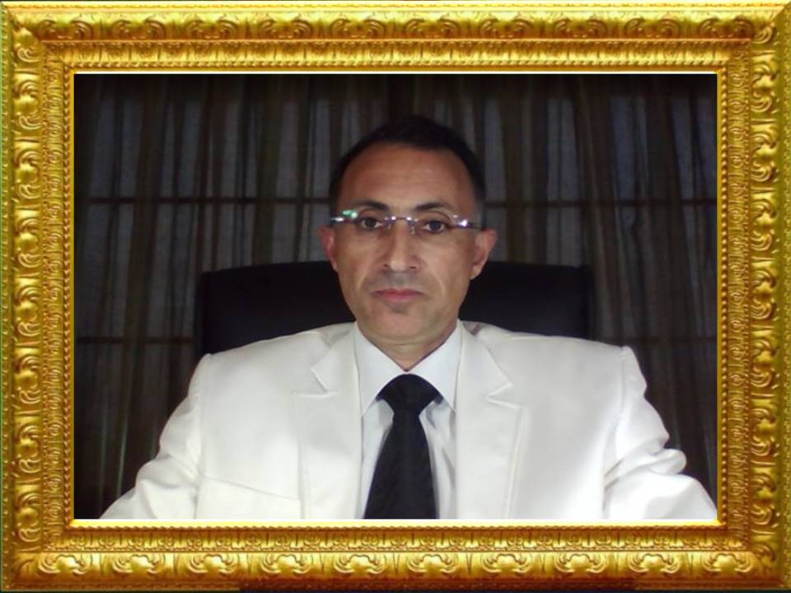

APEX DEGREE MEDICAL PHILOSOPHER EFRUZHU PHRMP
SUPREMO DOGMATIST EFRUZHU DOTMP
CONSULTANT MOLECULAR & CELLULAR ONCOLOGY AND CLINICAL MEDICAL ONCOLOGY (CARCINOGENESIS & ONCOTHERAPY DRUG DESIGN EXPLORATION DISCOVERY)
TURKISH REPUBLIC OF NORTHERN CYPRUS
NORTH CYPRUS TURKISH CYPRIOT

