CANCER PATIENT (ONCOLOGICAL PATIENT )
IS OWN DEEP-STRONG OXİDATIVE METABOLIC STRESS THAT WİLL HAVE BEEN CAUSED NEW CANCER CARCINOGENESIS,
NEW CANCER CELLS HAVE BEEN MAKING AND UNSUCCESSFUL CANCER TREATMENT - ONCOTHERAPY (MOLECULAR AND CLINICAL MEDICAL / NATURAL ANTICANCER ANTINEOPLASTIC DRUGS AGENTS .
FOR MATERIAL BODY (WITH TIME ):
EFRUZHU CANCER CARCINOGENESIS THEORY LAWS :
1.MUTATIONS GROUP IDENTITY
2.INADEQUATE ENERGY
3.CHRONIC INFLAMMATION
4.NORMAL DNA SUPPRESSION

WE HAVE TO MAKE SUPPORT FEEDING OUR SPIRITUAL BODY(TIMELESS) AS ANTIMATTER THAT OPPOSITION BALANCED FOR REMOVED DEEP – STRONG OXIDATIVE METABOLIC STRESS .

EFRUZHU SPIRITUAL BODY ONCOTHERAPY PROTOCOL ®©

DAYLY
- EARLY MORNING 7 MINUTES
- NOON 15 MINUTES
- AFTERNOON 10 MINUTES
- EVENING 8 MINUTES
- AT NIGHT 20 MINUTES

TREATMENT APPLICATION INTERVAL TRAINING HOURS :
1 – 7 – 4 – 3 – 1 – 8

UNTIL END OF TOTAL ONCOTHERAPY
MACROCYCLE - MACROTURNOVER

OPTIONAL SPIRITUAL BODY SUPPORTIVE - FEEDING CHOICES :
1.MYSTIC SONGS
2.HOLY QURAN READING
3.HOLY QURAN LISTENING
4.FIVE TIMES ISLAMIC WORSHIP
5.FIVE TIME PRAYER ,QUOTE ZİKİR , REPEAT HOLY WORDS (EXAMPLE : “ALLAH OR ALLAHU OR LAİLAHEİLLALLAH ETC.)



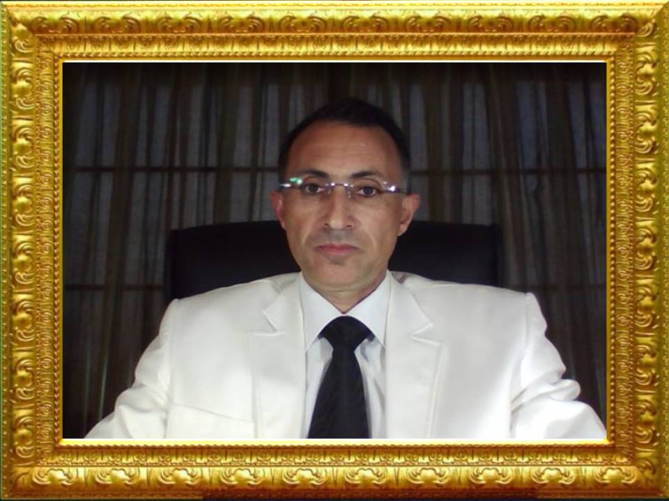

APEX DEGREE MEDICAL PHILOSOPHER EFRUZHU PHRMP

NORTH CYPRUS TURKISH CYPRIOT

MOLECULAR & CELLULAR ONCOLOGY AND CLINICAL MEDICAL ONCOLOGY CANCER CARCINOGENESIS AND ABSOLUTE ANY STAGE ONCOTHERAPY DRUG DESIGN
DISCOVERY ,EXPLORATION RESEARCHER

